USER’S MANUAL
Login your credentials
using email and password
email address: admin@gmail.com
password: password
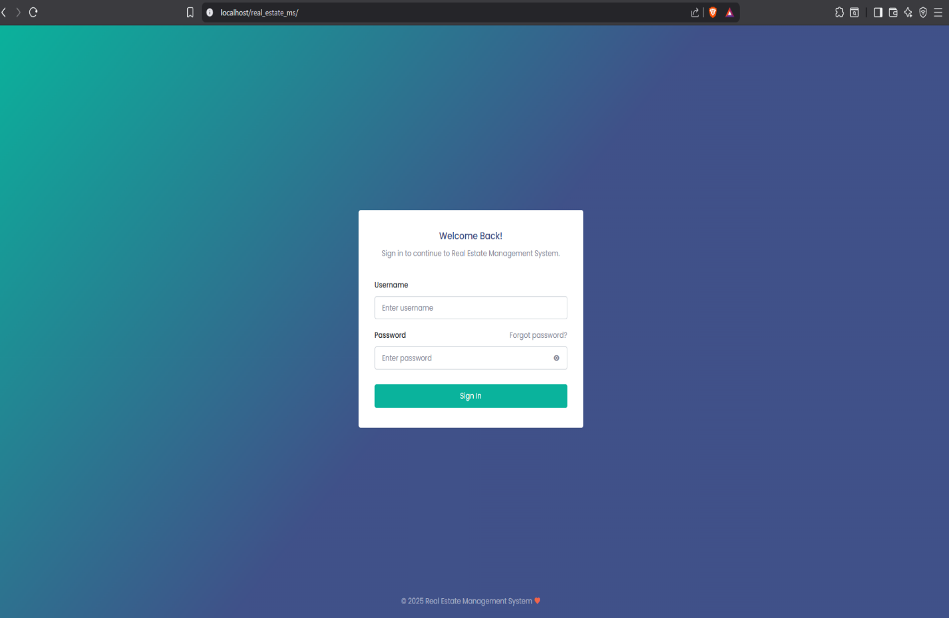

DASHBOARD
-Count Total Properties
-Count Total Occupied
-Count Total Available
-Count Total Tenant
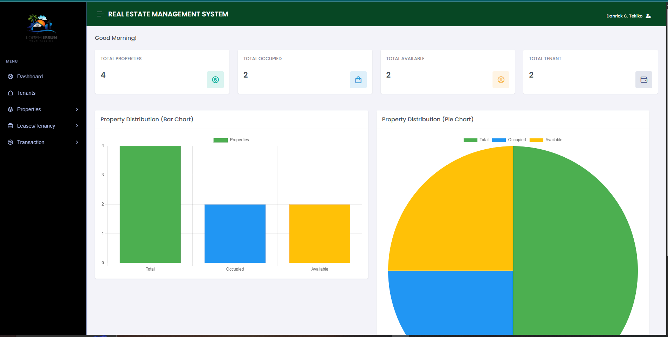

TENANT
Register All Tenant
Click Create Tenant Button to View the Modal
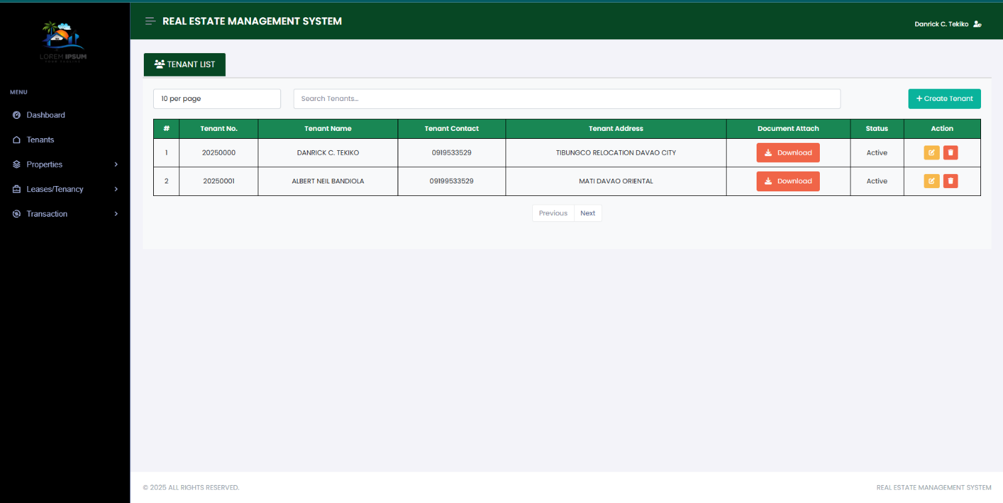

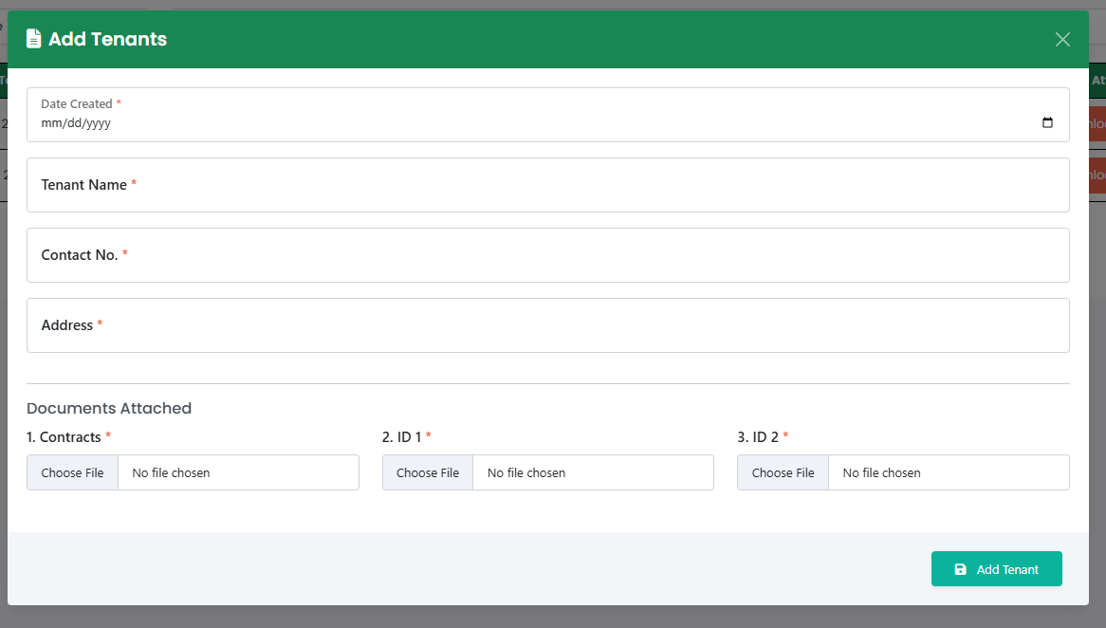

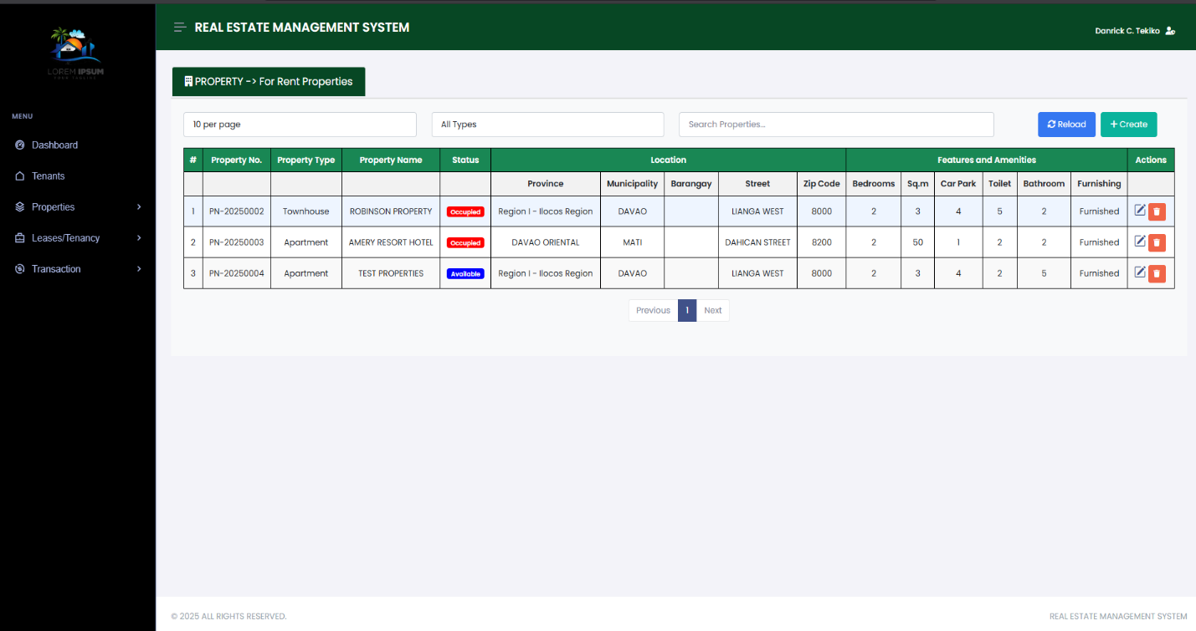
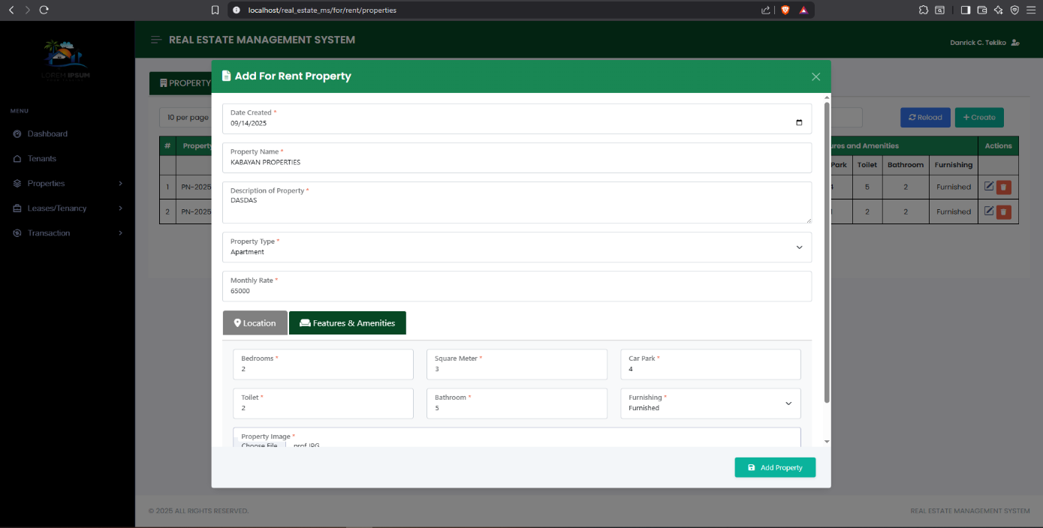
Properties
-In the Sidebar
-Create All For Rent Properties
-All Encoded Properties are Available Properties

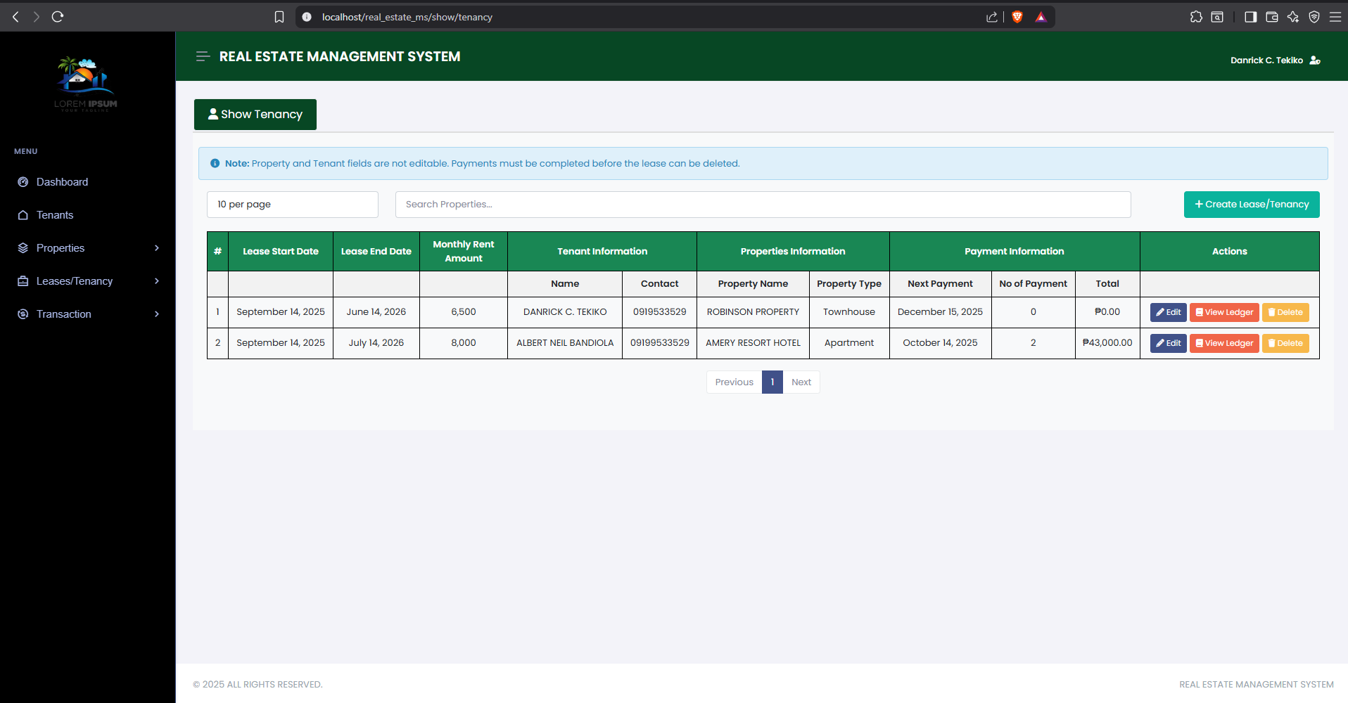
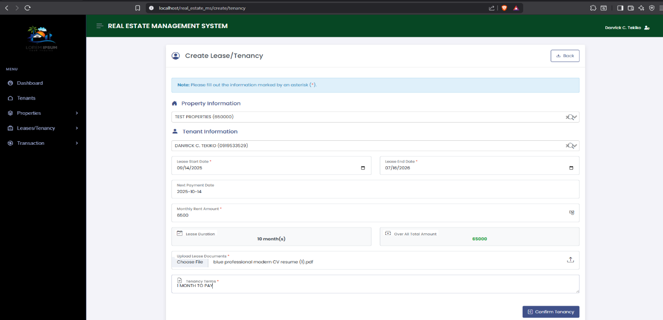
Leases/Tenancy
-Create Leases
-Show Tenancy

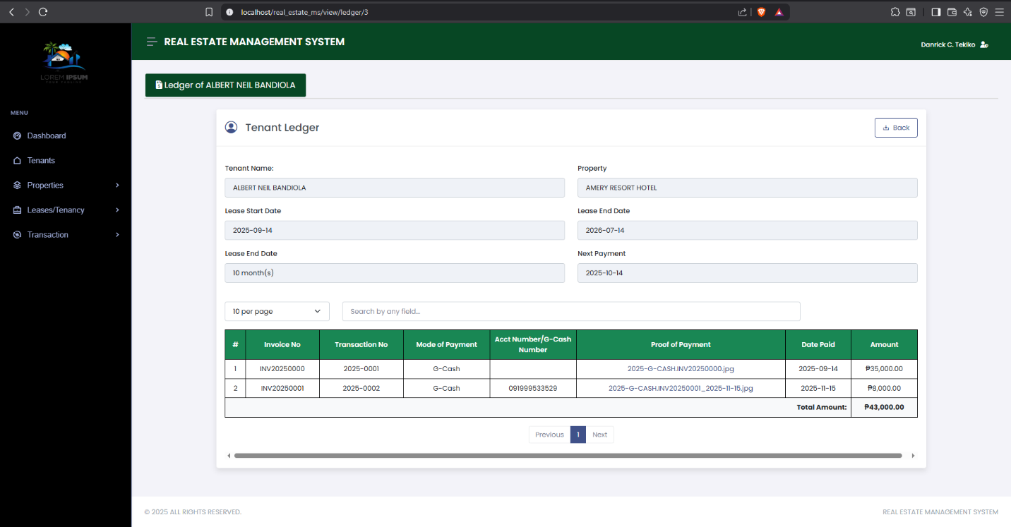
View Ledger of Tenant

